SQLite Database Design, JDBC Persistence & Testing
Implemented PlantsDB.db structure, JDBC connection, DAO responsibilities, CRUD mapping and isolated persistence tests
Evolution: Week 7 persistence proposal -> Week 9 implemented SQLite/JDBC solution

1. Database Objective
SQLite provides local persistence for the Plantopedia JavaFX application. The Week 9 implementation uses the repository-level PlantsDB.db database and a PlantsData table. Java accesses SQLite through JDBC, while SQLitePlantDAO encapsulates plant persistence so SQL is kept out of the JavaFX presentation layer.

2. Design Evolution
Earlier Week 7 proposal | Week 9 implementation | Documentation treatment
Multiple tables including users, plants, favourites, distributions and sources. | Current plant persistence is centred on PlantsDB.db -> PlantsData. | Document the earlier structure as a future/normalised direction, not as currently implemented.
plants table with common_name, habitat, growing and safety fields. | PlantsData contains 14 identifier, descriptive, distribution and taxonomy columns. | Replace the old SQL schema as the current schema.
DatabaseManager / DatabaseInitializer concept. | DatabaseConnection provides JDBC connections; test setup creates isolated test schema. | Use actual class names and clearly distinguish production connection from test setup.
Basic PlantDAO planned. | SQLitePlantDAO now performs CRUD, retrieval, search, count and pagination. | Mark DAO persistence as implemented.
A few persistence tests planned. | SQLite DAO and model tests now exercise persistence and edge cases. | Add a dedicated persistence-testing section.

3. Current Physical Database
PlantsDB.db
└── main
└── PlantsData
└── PlantID (unique identifier / key)
SQLite also exposes internal metadata such as sqlite_master. This is an SQLite system catalogue and is not part of the Plantopedia application domain model.

4. Implemented PlantsData Schema
Column | SQLite type | Purpose
PlantID | INTEGER / INT | Primary identifier; database-generated for new records.
Generalised_info | VARCHAR / TEXT | General plant information.
images | VARCHAR / TEXT | Image reference/data.
stateProvince | VARCHAR / TEXT | Geographic occurrence.
scientificName | VARCHAR / TEXT | Scientific name.
kingdom | VARCHAR / TEXT | Taxonomic kingdom.
phylum | VARCHAR / TEXT | Taxonomic phylum.
class | VARCHAR / TEXT | Taxonomic class.
order | VARCHAR / TEXT | Taxonomic order.
family | VARCHAR / TEXT | Taxonomic family.
genus | VARCHAR / TEXT | Taxonomic genus.
taxonRank | VARCHAR / TEXT | Taxonomic rank.
vernacularName | VARCHAR / TEXT | Common/vernacular name.
species | VARCHAR / TEXT | Species information.

5. JDBC Connection Architecture

JavaFX / application code
↓
IPlantDAO abstraction
↓
SQLitePlantDAO
↓
DatabaseConnection.getConnection()
↓
SQLite JDBC driver
↓
PlantsDB.db -> PlantsData

DatabaseConnection centralises the JDBC URL and connection creation. The normal/default connection targets PlantsDB.db. For automated tests, the database URL can be redirected to a temporary SQLite file so tests do not insert, update or delete records in the team's real database.

6. DAO Design
IPlantDAO defines the plant persistence contract. MockPlantDAO can satisfy that contract using in-memory objects, while SQLitePlantDAO provides the persistent implementation. This allows UI/application code to depend on the DAO abstraction rather than on SQLite-specific SQL.
IPlantDAO
/ \
/ \
MockPlantDAO SQLitePlantDAO
(in memory) |
JDBC
|
PlantsDB.db

7. CRUD and Query Mapping
Capability | DAO operation | Persistence behaviour
Create | addPlant(Plant) | INSERT a plant record and assign the generated PlantID back to the Plant object.
Read one | getPlant(id) | SELECT the record matching PlantID; return null when no plant exists.
Read all | getAllPlants() | SELECT persisted plant records and map each row to a Plant object.
Update | updatePlant(Plant) | UPDATE the matching PlantID using the Plant object's current field values.
Delete | deletePlant(Plant) | DELETE the record matching the PlantID.
Search | search(query, limit, offset) | Search persisted plant data and return a bounded page of results.
Count | count(query) | Return the total number of matching records to support pagination.

8. Prepared Statements and Mapping
SQLitePlantDAO uses PreparedStatement values rather than constructing SQL by concatenating plant data. Each Plant field is mapped to the corresponding PlantsData column. The implementation also handles the generated database identifier after insertion.
Plant object
generalisedInfo ─────────→ Generalised_info
images ──────────────────→ images
stateProvince ───────────→ stateProvince
scientificName ─────────→ scientificName
...
vernacularName ─────────→ vernacularName
species ────────────────→ species

9. Persistence Testing Strategy
Persistence tests are isolated from PlantsDB.db. Before each SQLitePlantDAO test, a temporary SQLite database file is created, DatabaseConnection is redirected to that file, and the PlantsData schema required by the DAO is created. After the test, the normal database URL is restored and the temporary database can be removed.
JUnit test
↓
@BeforeEach
├─ create temporary .db
├─ redirect DatabaseConnection URL
└─ create PlantsData test schema
↓
SQLitePlantDAO operation
↓
Temporary SQLite database
↓
Assertions
↓
@AfterEach -> restore normal database configuration / clean up

10. Test Coverage Implemented
Test area | What it verifies
Database connection | A connection can be opened to an existing/temporary SQLite database.
Add / generated ID | A plant is inserted and receives a database identifier.
Full field persistence | All implemented Plant fields survive a database round trip.
Read one | An existing plant can be retrieved; a missing ID returns the expected null behaviour.
Read all | Multiple plants can be returned; an empty database returns an empty collection.
Update | Changes to one plant persist without incorrectly modifying another plant.
Delete | An existing plant can be removed; deleting a missing plant does not corrupt the database.
Special characters | Text containing punctuation/special characters persists correctly through prepared statements.
Search | Matching persisted records are returned.
Pagination | Search supports page size/offset behaviour, including consecutive 20-record pages.
Isolation | Tests operate on temporary databases rather than mutating the shared PlantsDB.db.

11. Week 9 Implementation Status
Deliverable | Status | Evidence
SQLite connection | Implemented | DatabaseConnection and successful connection test.
PlantsData persistence | Implemented | SQLitePlantDAO maps Plant objects to the existing schema.
CRUD | Implemented | Add, retrieve, update and delete behaviour tested.
Search and pagination | Implemented | Search/count/limit/offset behaviour covered by DAO tests.
Model tests | Implemented | Plant getters/setters and object-state/edge-case behaviour tested.
UI integration with persistent DAO | Next integration step | JavaFX pages can be wired to the DAO contract as the team integrates features.
Normalised distributions/sources/safety | Future refinement | Retained as a possible later schema evolution if required by user stories.

12. Iteration from the Original Database Design
The Week 7 document proposed a broader normalised database to support future favourites, distribution and research provenance. The Week 9 implementation intentionally follows the database and plant dataset now used by the team. This is an Agile refinement rather than a loss of the earlier design: the current schema delivers the persistence required by the present sprint, while the earlier relational concepts remain available for future stories that justify them.

13. Selected JDBC and Persistence Test Code Evidence
The following excerpts document the implementation that was exercised during the Week 9 persistence work. They are included as evidence of the connection strategy, isolated test database setup, prepared-statement CRUD operations and TDD-oriented persistence verification. The complete source remains in GitHub and should be treated as the authoritative implementation.
Snippet 1 - Default SQLite JDBC target in DatabaseConnection
private static final String DEFAULT_DATABASE_URL =
"jdbc:sqlite:PlantsDB.db";
private static String databaseUrl = DEFAULT_DATABASE_URL;

The application connection defaults to the repository-level PlantsDB.db file. The connection class also supports redirecting the URL during automated tests, allowing production data to remain untouched.

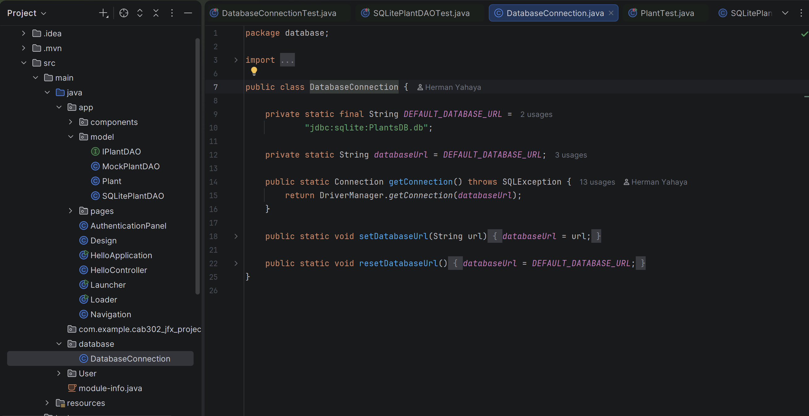

Snippet 2 - SQLitePlantDAOTest isolated temporary database setup
@BeforeEach
void setUp() throws Exception {
// Create a temporary SQLite database file for this test
testDatabasePath = Files.createTempFile("plantopedia-test-", ".db");
// Redirect DatabaseConnection to the temporary test database
DatabaseConnection.setDatabaseUrl(
"jdbc:sqlite:" + testDatabasePath.toAbsolutePath()
);
// Create the PlantsData schema required by SQLitePlantDAO
try (Connection connection = DatabaseConnection.getConnection();
Statement statement = connection.createStatement()) {
statement.execute("""
CREATE TABLE PlantsData (
PlantID INTEGER PRIMARY KEY AUTOINCREMENT,
Generalised_info VARCHAR(512),
images VARCHAR(512),
stateProvince VARCHAR(512),
scientificName VARCHAR(512),
kingdom VARCHAR(512),
phylum VARCHAR(512),
class VARCHAR(512),
"order" VARCHAR(512),
family VARCHAR(512),
genus VARCHAR(512),
taxonRank VARCHAR(512),
vernacularName VARCHAR(512),
species VARCHAR(512)
)
""");
}
}
This is particularly important for repeatable unit testing: each test can work against a disposable SQLite file rather than inserting, updating or deleting records in the team database.
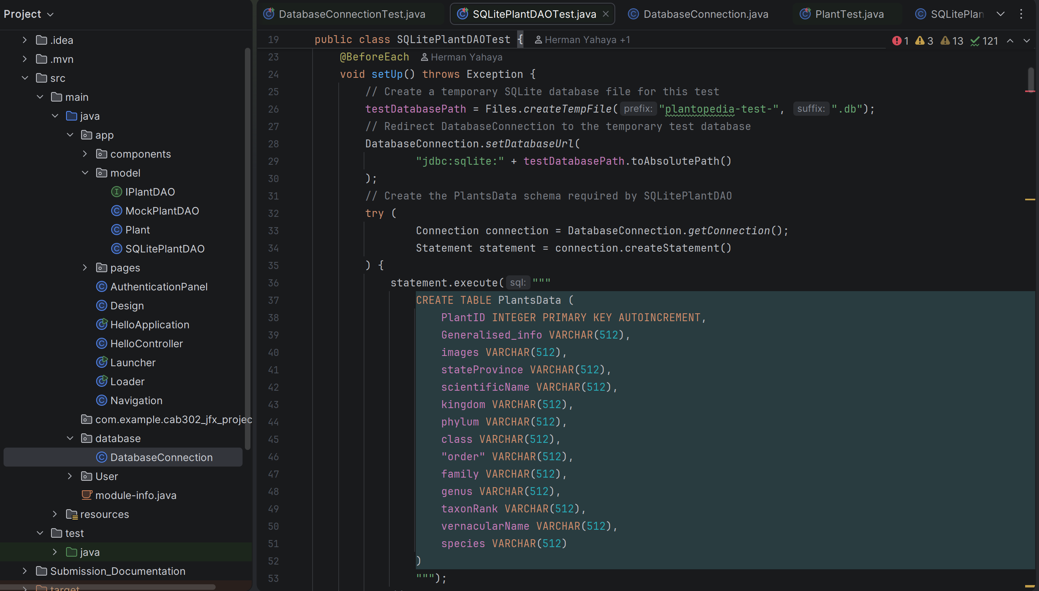
Snippet 3 - Prepared-statement delete persistence
String sql = """
DELETE FROM PlantsData
WHERE PlantID = ?
""";
try (Connection connection = DatabaseConnection.getConnection();
PreparedStatement statement = connection.prepareStatement(sql)) {
statement.setInt(1, plant.getId());
statement.executeUpdate();
} catch (SQLException e) {
throw new RuntimeException("Failed to delete plant from database", e);
}

The SQLitePlant DAO follows the prepared-statement pattern for INSERT and UPDATE operations. Plant values are bound to placeholders instead of being concatenated directly into SQL.
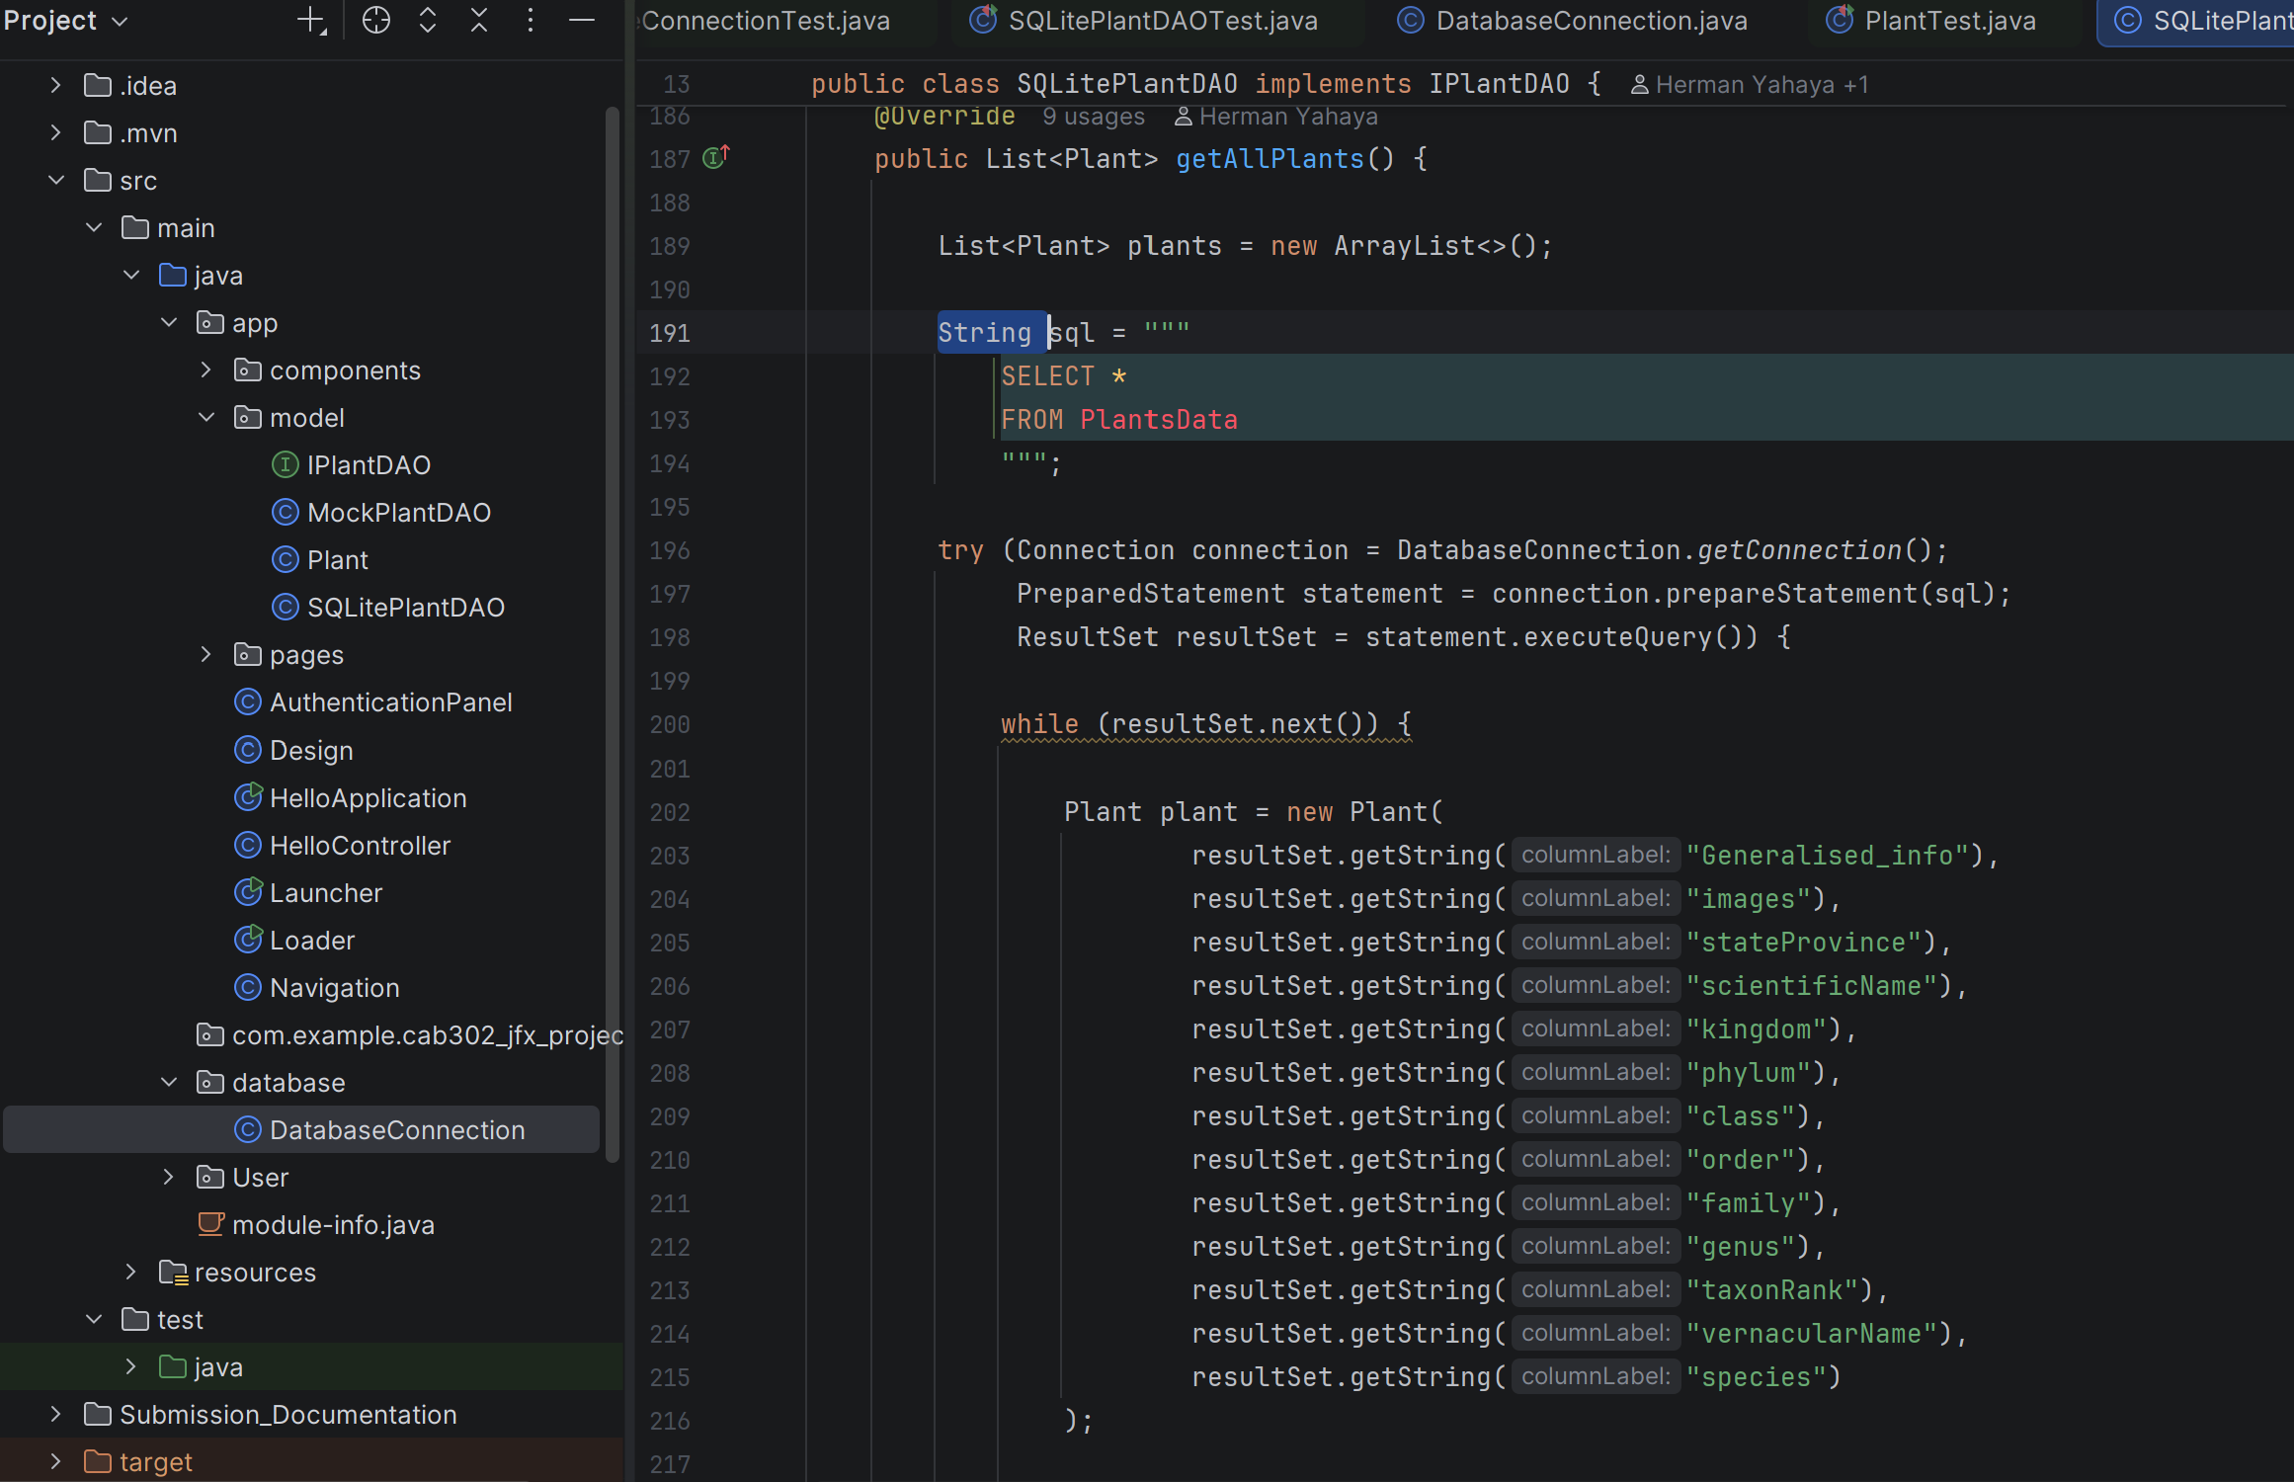

Snippet 4 - Representative persistence behaviours covered by tests
// Examples from the implemented SQLitePlantDAOTest suite
addPlantShouldPersistPlantToDatabase()
updatePlantShouldPersistChangesToDatabase()
deletePlantShouldRemovePlantFromDatabase()
getAllPlantsShouldReturnAllPlantsFromDatabase()
multiplePlantsShouldPersistIndependently()
deleteNonExistentPlantShouldNotAffectDatabase()
updatingOnePlantShouldNotAffectAnotherPlant()
plantWithSpecialCharactersShouldPersistCorrectly()
searchShouldSupportTwentyPlantPages()
allPlantFieldsShouldPersistAndBeRetrievedCorrectly()
getPlantShouldReturnNullWhenPlantDoesNotExist()
At the latest local run shown during integration, SQLitePlantDAOTest completed successfully with 16 tests passing. This provides evidence for CRUD behaviour, retrieval, edge cases, field mapping and larger search/pagination behaviour after the merge-conflict resolution.
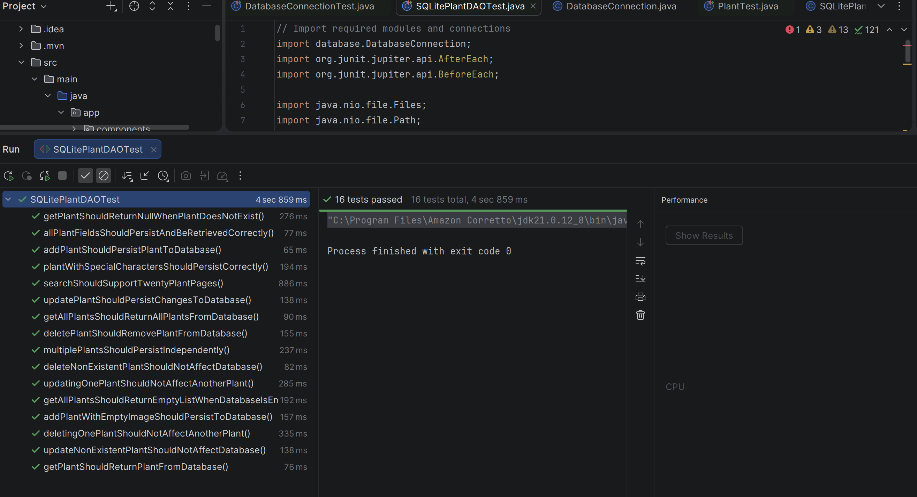

14. TDD Evidence in the Feature Branch
The feature branch history records persistence work as small test/implementation steps, including a failing addPlant persistence test followed by its implementation, a failing updatePlant persistence test followed by its implementation, generated-ID verification, broader JDBC tests and later edge-case coverage. This history is useful checkpoint evidence because it shows tests being used to drive and verify persistence behaviour rather than being added only after the feature was complete.

